QGIS Workflow for Hardin Branch Watershed Assignment

1. Install QGIS 3.34.x (most current is 3.34.8) or some equivalent:
2. Install/activate plugins:
   1. SRTM downloader (used to get NASA provided global DEM on 30x30 m pixels)
   2. SAGA - System for Automated Geoscientific Analyses (want Next GEN)
   3. Coordinate Capture
3. Start QGIS:
   1. Open existing project or create a new one
   2. Load Open Street Map (from XYZ Tiles or Data Source Manager)
   3. 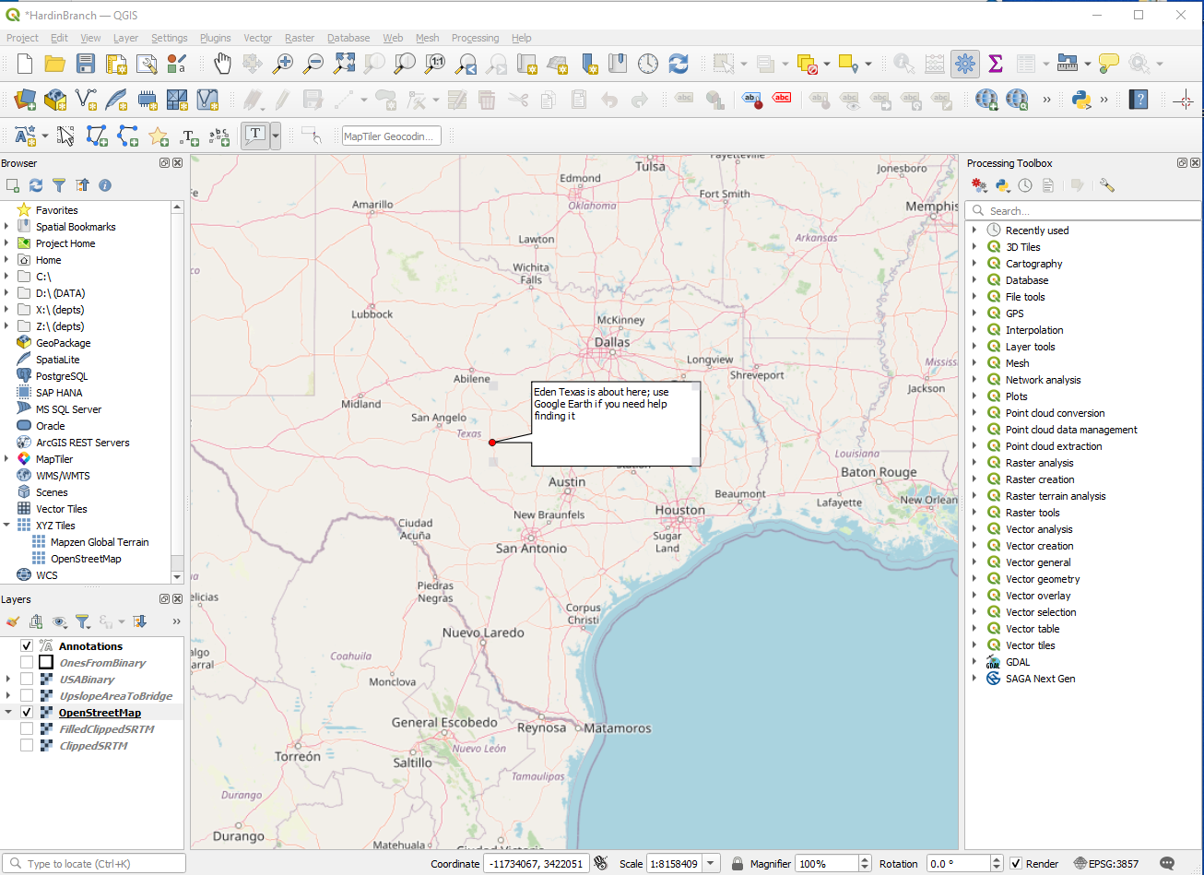
   4. Zoom to region of interest (Near Eden, Texas) 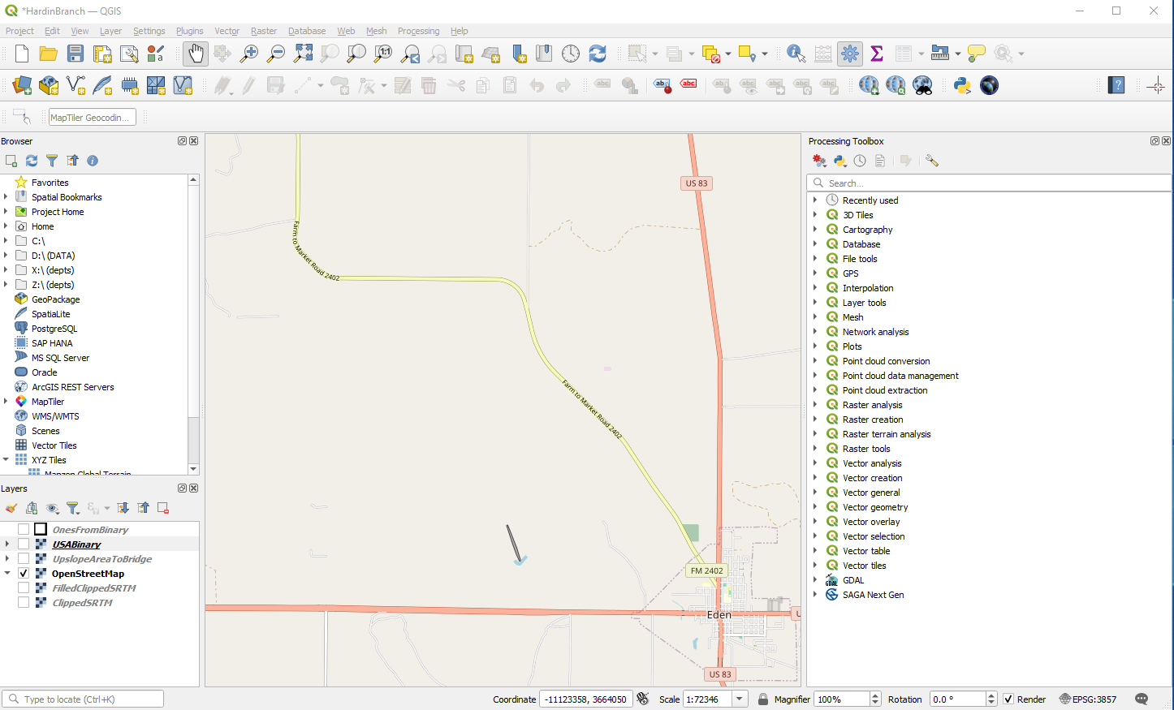
   5. SAVE the project at this point. You should be able to return to this zoom level if things get cluttered. Make note of the CRS WGS-84 Pseudo Mercator EPSG 3857. When you get DEM data you have to re-project into this CRS for the other tools to work.
   6. Obtain SRTM data using SRTM downloader. Set the search area to Canvas Extent (it’s the button in the middle of the dialog) 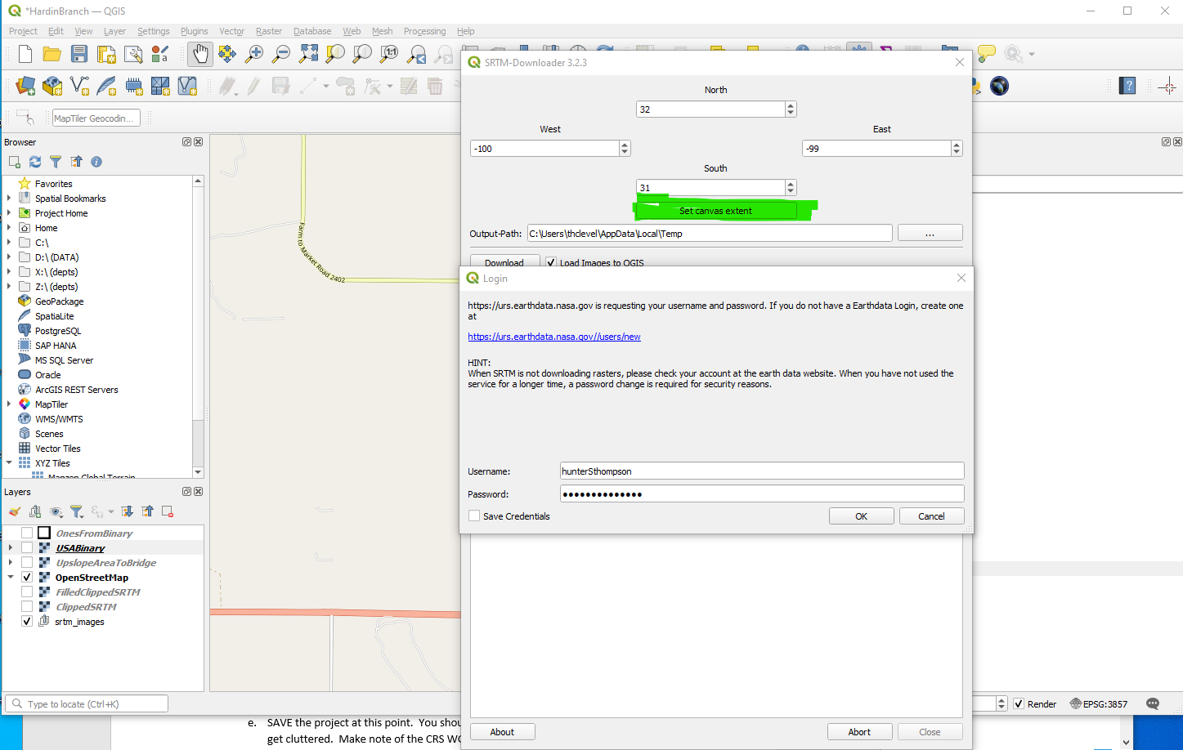
   7. Choose Download and enter your NASA credentials (If you don’t have any, it will route to an account creation page; as long as you have paid your taxes, and are not wanted by Interpol, and have not deserted from any military it should allow you to make an account).
   8. 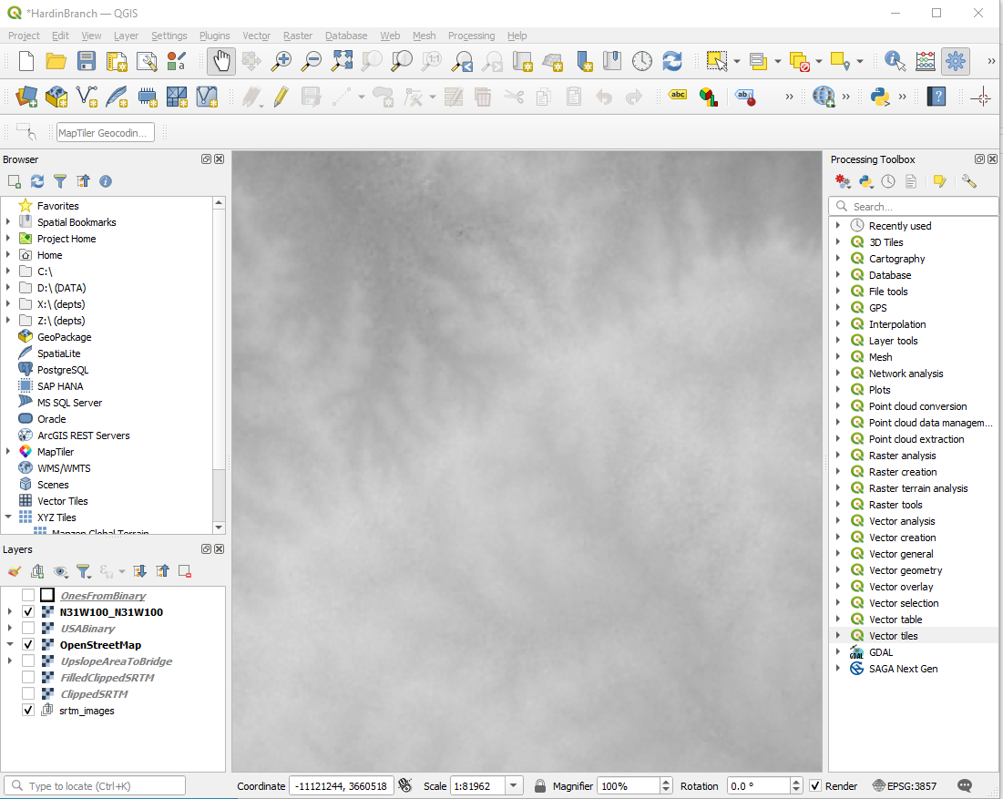

Notice the background changes to show the DEM data (you can fix it so the street map overlays the DEM). 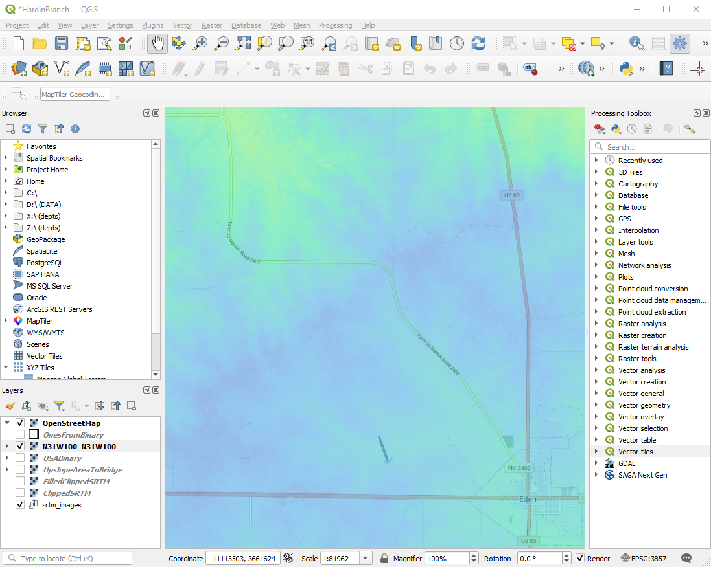Click OK; then save the project.

* 1. Re-project the DEM target CRS is 3857 Raster/Projections/Warp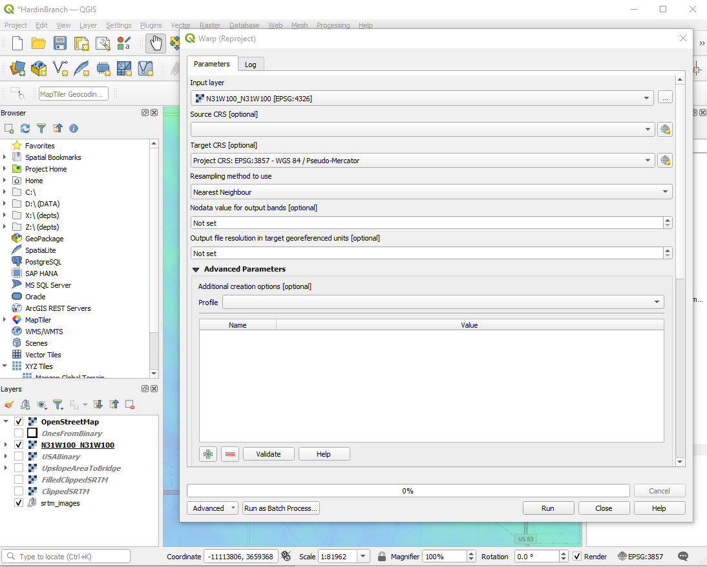

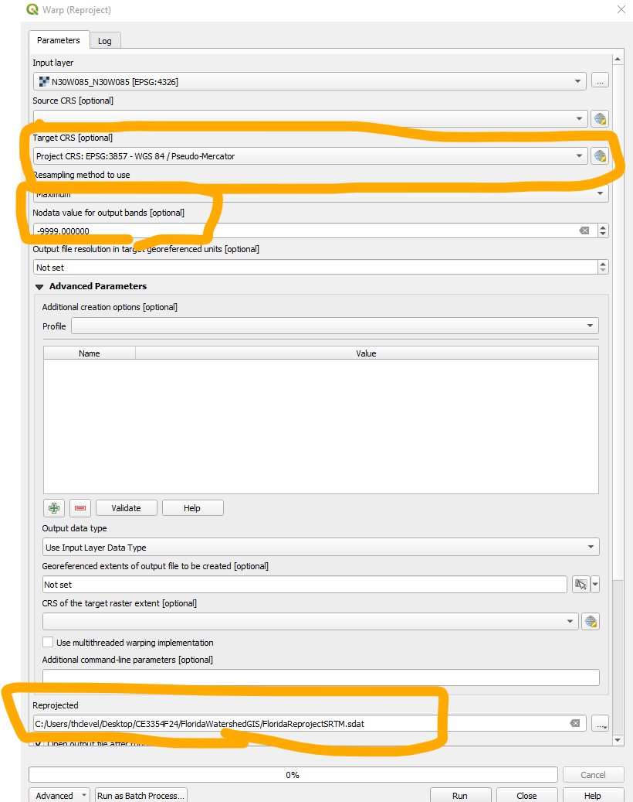

Remember to:

1. Set the source to an elevation raster (not Open Street Map)
2. Set the CRS to one of the Cartesian types (WGS 84 Psuedo Mercator is my favorite)
3. Set some weird (easy to filter) numeric value to No Data
4. Set an ACTUAL file for the reprojected raster (you need this so you can recover files days later)
   1. We now remove the SRTM layers, and save the remaining project. Can mess with the DEM rendering and OpenStreetMap to get something like: 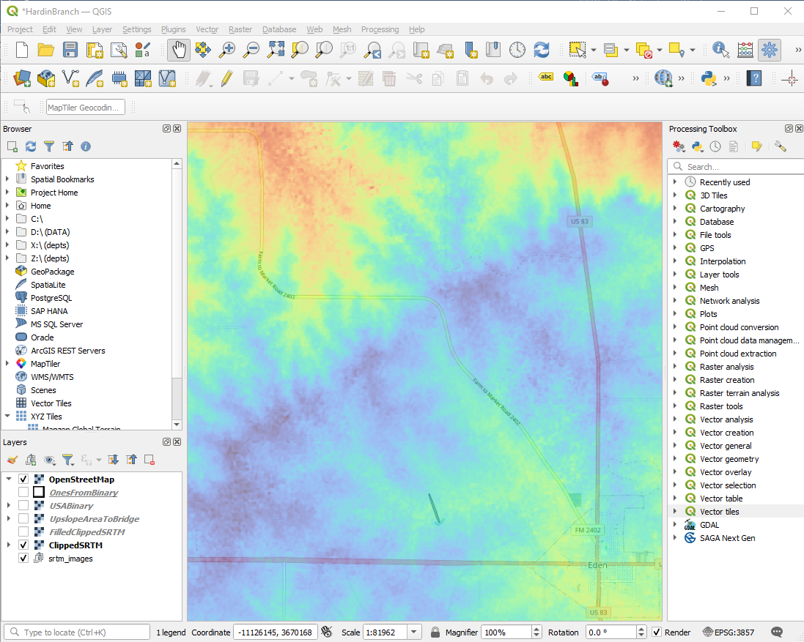
   2. Now we want to clip the DEM save the clipping and toss the big file. Raster/Extract does this; save as a .tif file. Remember to:
5. Size the view to encompass best guess of just enough area to enclose the watershed
6. Select the correct source file; it should be the DEM you just created.
7. Select a memorable file name for output, save as .tif file.
   1. 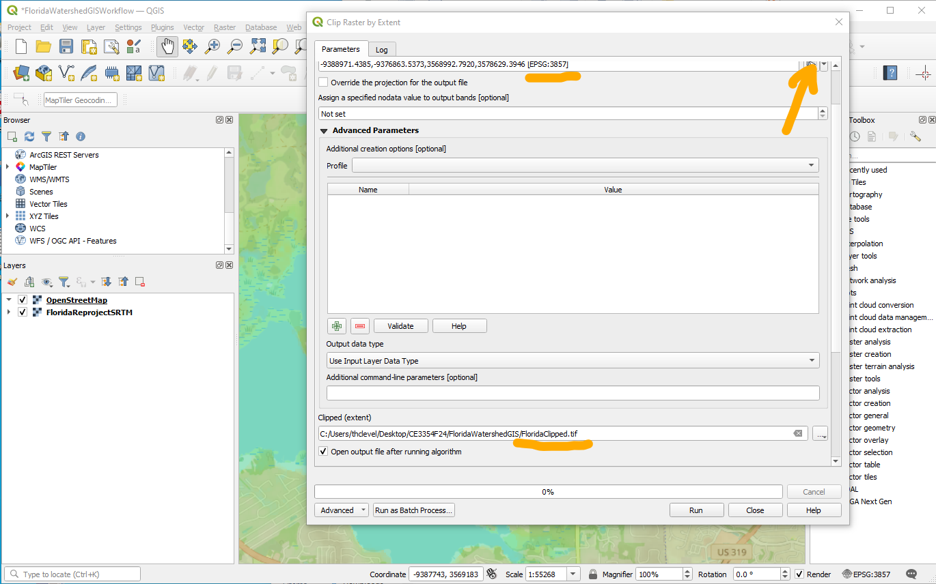
   2. After clipping and some rendering/symbology adjustments. 
8. Now use SAGA to make a sink-filled file.
   1. Select SAGA from processing toolbox (on right column, or menu from top)
   2. Choose Wang and Liu sink fill in Terrain Analysis-Hydrology
   3. Select correct source file
   4. Choose a meaningful name for the output file
   5. Disable the last two options, but keep the filled DEM option
9. 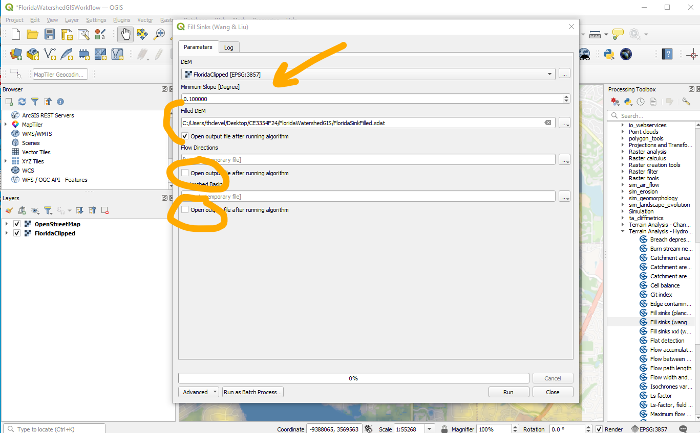
10. This process takes a long time and uses a lot of RAM, so that’s partly why we clipped the area. 16GB seems to be enough RAM; My 8GB laptop is too small for the algorithm to work. Figure is sink filled, and zoomed out a little to show effect of clipping.

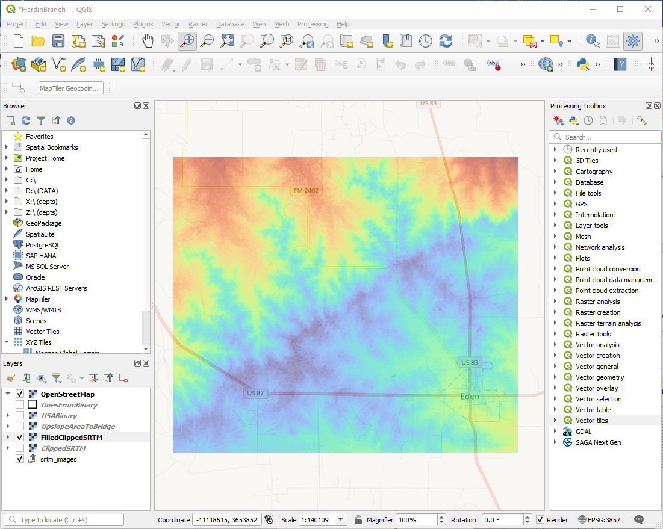

1. Now find the outlet.
2. Zoom into near outlet
3. Change rendering to Hillshade to help locate suitable cells to get coordinates from. Use hillshade to help find locations, notice the coordinate capture tool leaves a small red dot. Next use SAGA upslope area to find all the cells upstream of the coordinate
4. Once have a good guess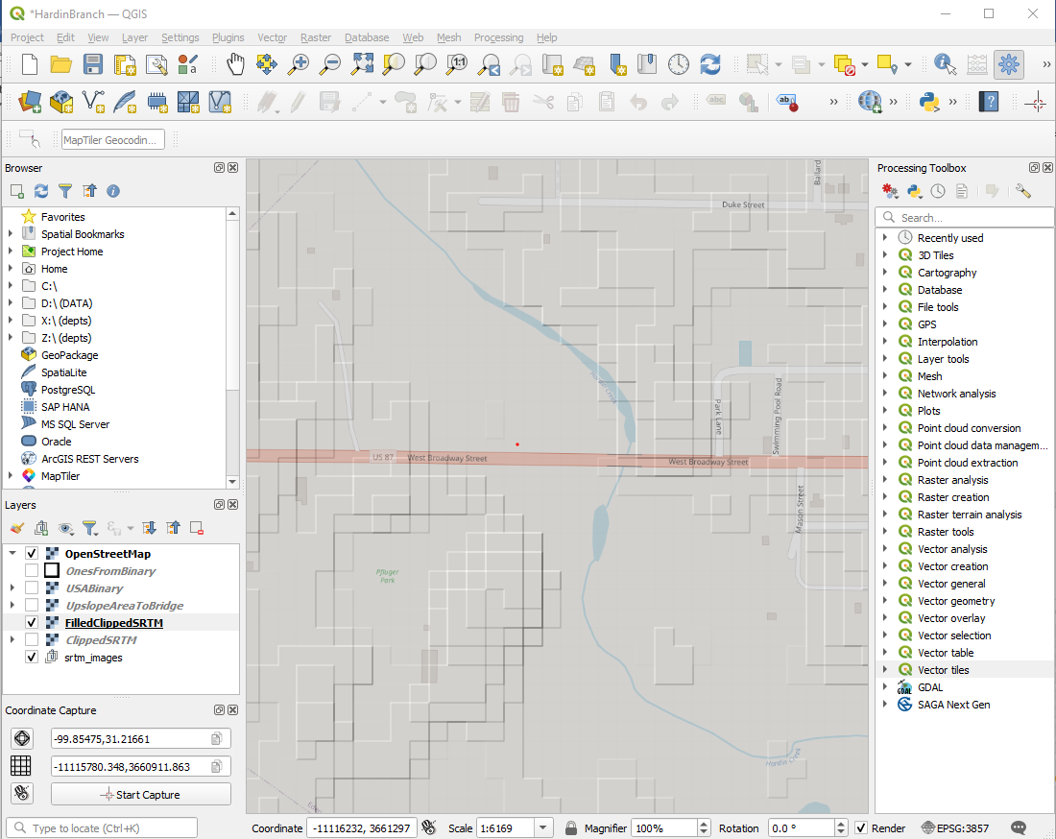

Then transfer the coordinates to the SAGA Upslope Area calculator. And run the script. Substantial trial and error may be needed to move the point around until get a believable rendering of the watershed. Keep in mind that there are at least 2 coordinate transformations to this point, so no expectation for the stream drawing in Open Street Map and the DEM to line up – but they are usually close.

As in above steps, choose memorable file names for the upslope area, and run the script.

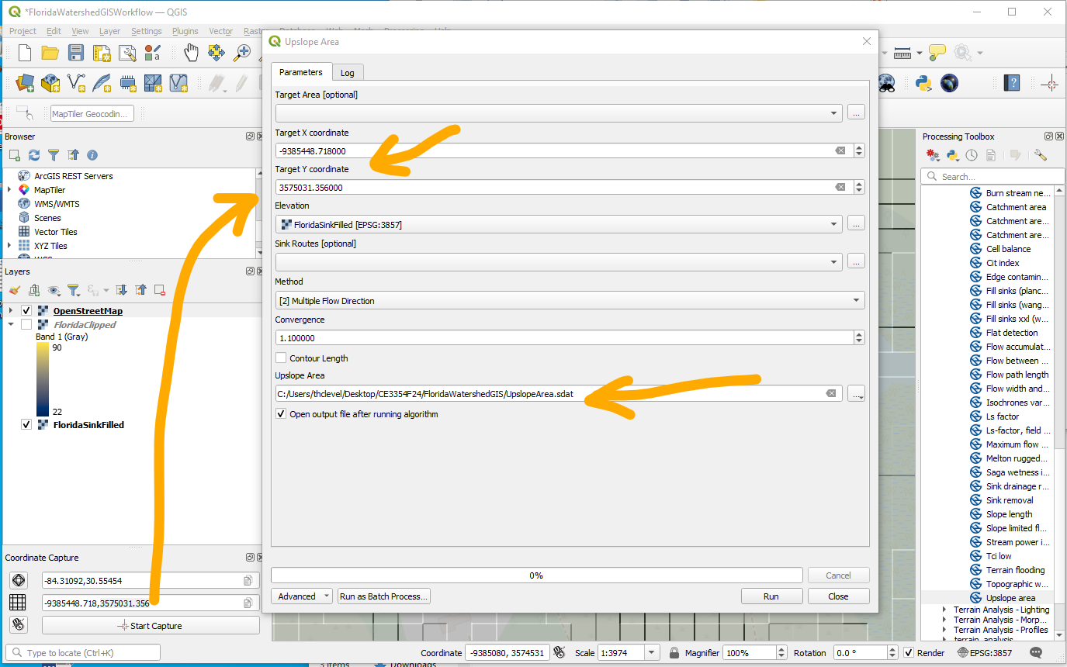

1. The output is a raster of the watershed 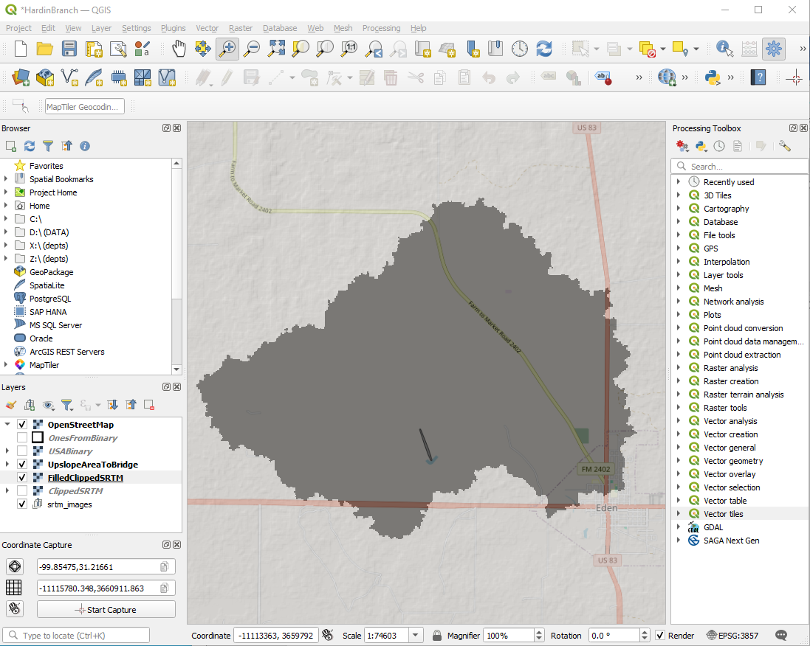
   1. This is a good time to save work so far.
2. Now to compute area (as per assignment)
   1. Use the area measure tool for a quick measurement. 17.656 mi²
   2. Notice bigger than by-hand, because some area south of the highway is included that probably does not contribute; and the vy-hand omits some area to the Eas t of US83.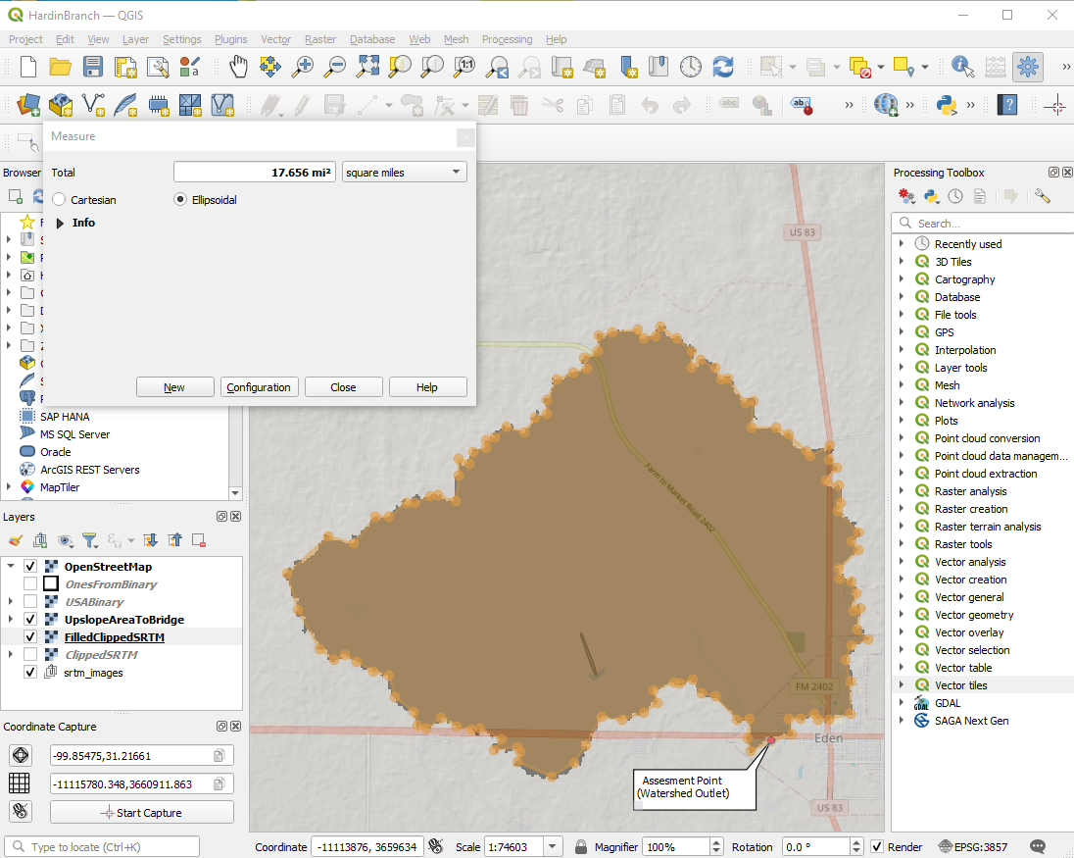
   3. We can check by measuring the excess areas and subtracting them from the estimate so the comparable area is 17.047 mi² as compared to 16.93 mi² using paper maps and counting squares. (Less than 12% under-report, assuming GIS is the true value)
3. To make a better render.
   1. Use Raster calculator to extract Ones. (UpslopeArea < 50 => WatershedOnes)
   2. Use Raster Conversion to vectorise WatershedOnes => WatershedContribute.
   3. Use this WatershedContribute vector to mask the fill layer Raster/Extract/by Mask, and produce a DEM of just the watershed.
   4. Now render the final DEM 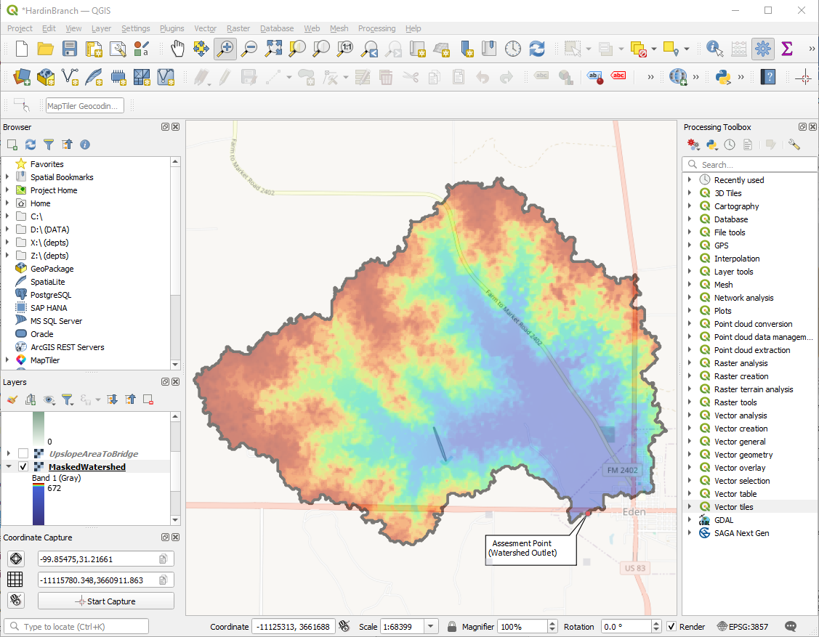
4. Now we can use measuring tools to get areas., and lengths.
   1. Area: Use measuring tool, or sum up the masked values and multiply by the pixel size. Should obtain about same value (use the pixel sum approach for areas that are really large – it would be more accurate)
   2. Channel length(s): Use measuring tools as below: 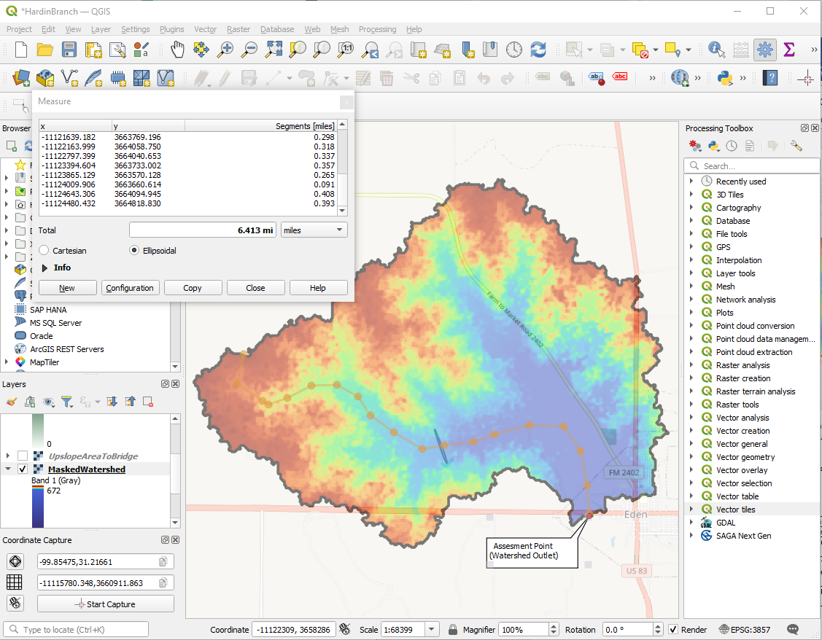
   3. 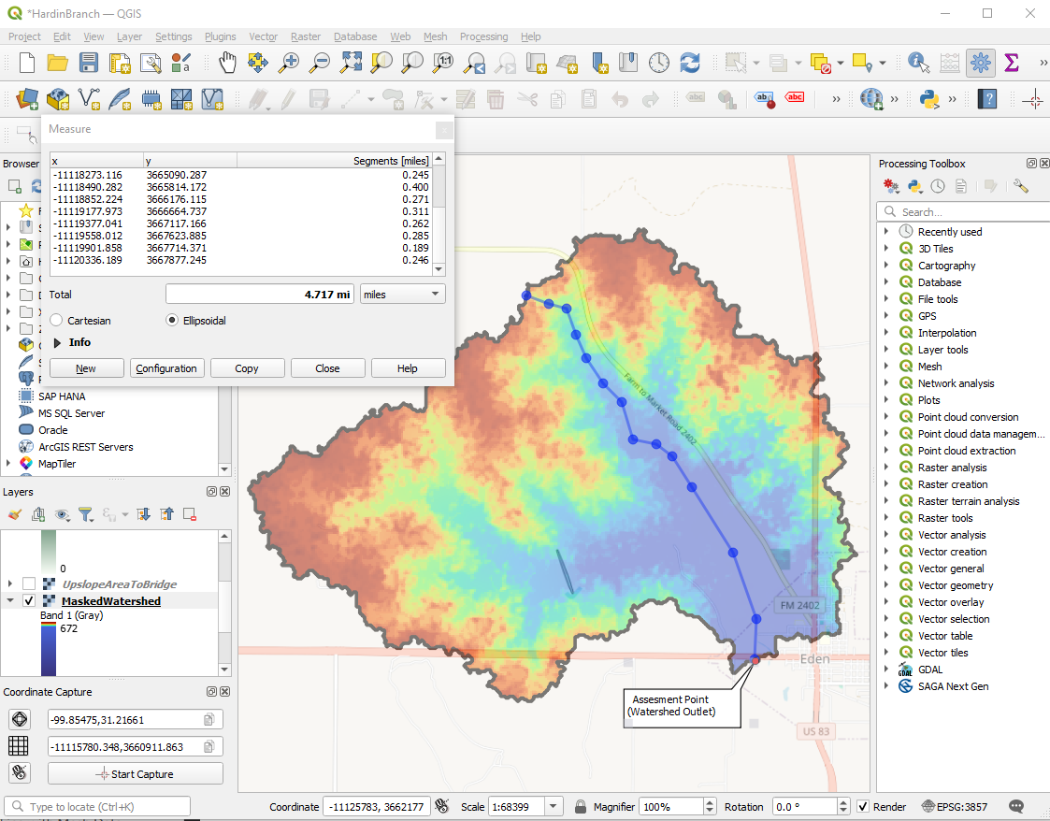
   4. Profile(s): Designate DEM as elevation data. Then use VIEW/ELEVATION to render profile along a path. 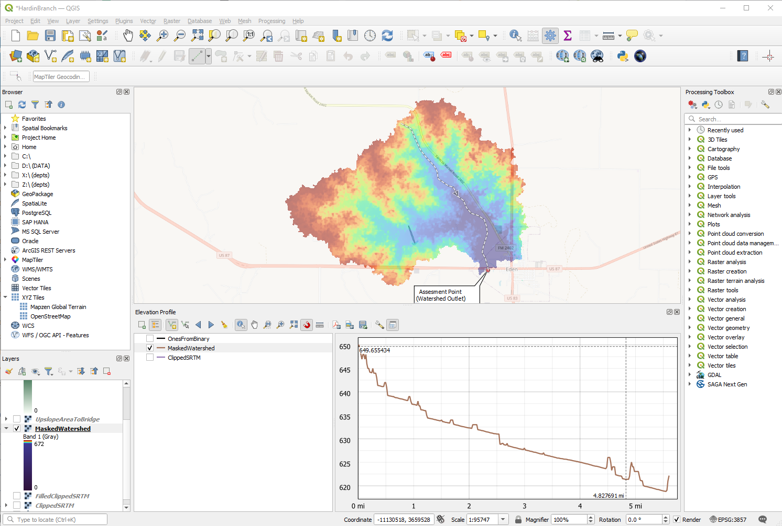  
      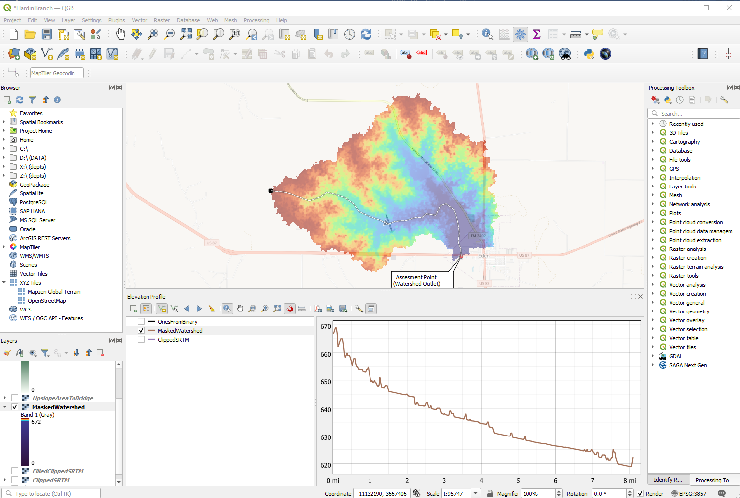
   5. Change scales/units as needed using the tools, or the grid scale and offset features.
5. Summarize in a Table (for typical homework)

|  |  |  |  |
| --- | --- | --- | --- |
| Item | Value | Units | Remarks |
| Area | 17.656 | Square Miles | GIS Area Tool |
| Main Channel Length (MCL) | 8.08 | Miles | GIS Line Tool/Profile Tool |
| Elevation Change along Main Channel | (670-621.7)*3.28 = 158 | Feet | Read from Profile |
| Average Main Channel Slope (MCS) | (158)/(8.08*5280) = 0.003 | Feet/Feet | Calculation |